555 timer

the 555 timer is an IC (integrated circuit) used in electronics projects. This type of IC can be used among different application such as oscillator to generate clock signals in order to create synchronized circuits and can also be configured as flip flops.

Released to the market in 1971 by the American company Signetics and known for its low cost the 555 timer registered a high percentage of purchases over the recent years (estimation: A billion units were manufactured back in the 2003 alone).

This type of ICs are used easily and provides a low power consumption since they belong to the CMOS family.

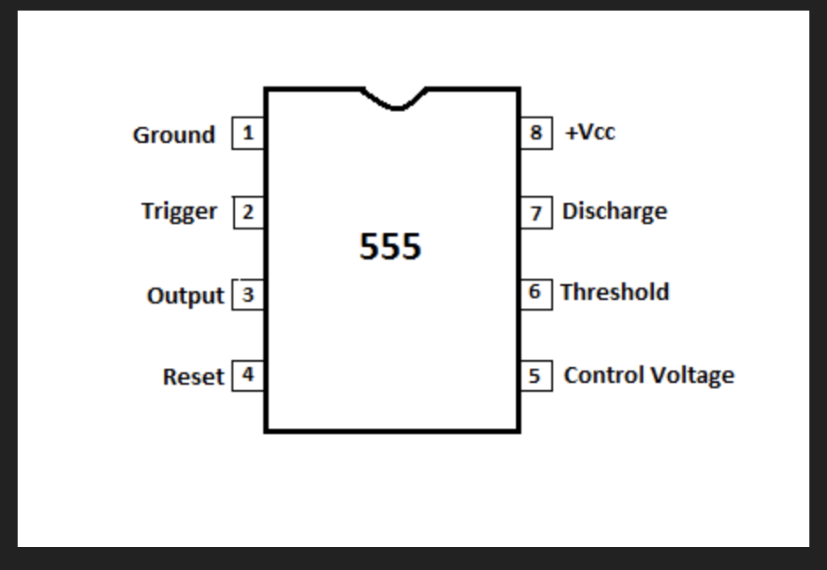

The table below provides highlighted information that characterizes the 555 timer:

|  |  |
| --- | --- |
| Composition | specifications |
| 25 transistors | Low cost |
| 2 diodes | Low power consumption |
| 15 resistors | CMOS family |
| 8 pins | 3 states |

The 555 timer is also known for his various features:

A voltage source ranging between 5V and 18V can be applied to the IC.

Due to his high current output a TTL circuit can be driven from the 555 timer.

Its duty cycle is can be adjustable to fit the purpose designer.

In addition to the mentioned information before the 555 timer can be used to generate oscillations hence create clock signals having adjustable frequencies and thus adjustable periods. The 555 timer is also set to be working as flip flop

Before we dig deeper into the detailed information and characteristic of the 555 timer it is crucial to discuss the three different operation mode of the 555:

Concerning the Astable mode the outputs will be varying between high and low frequency hence the output will not be stable and thus the unstable output as a clock or square wave output for various purposes. Talking next about the monostable state it is important to mention that the configuration consists about one stable (set to high or low by the user) and one unstable state ex: If the stable output is set at high (1), the output of the timer is high (1) whether in bistable mode the outputs are both stable ex: if we have a high (1) output, it will go low(0) once it receives an interrupt and stays low (0) till the next interrupt changes the status.

Concerning the 555 timer we will now discuss more about its structure how it is used.

First the 555 timer has mainly 8 pins as shown in the figure below:

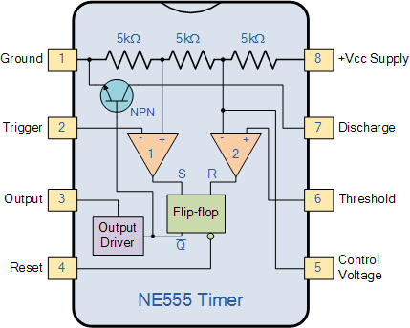

**It can be highlighted that the figure shows three 5kΩ from which have the name 555 timer**.

Trigger is connected to one on of the comparators which in turn is connected to S of the flip-flop.

Threshold is connected to one of the comparators which in turn is connected to R. The control voltage is connected to the comparator and thus is a reference to compare to when needed.

The three resistors act as voltage dividers. We have mainly 2 voltage comparators each connected to 1/3Vcc to non-inverting terminal of comparator 2 and 2/3 Vcc to inverting terminal of comparator 1.

When the threshold is higher than that of the **2/3 Vcc** the FF **resets.** Thus, we have a low output.

When the trigger is less than that of the **1/3 Vcc** the FF **sets**. Thus, we have a high output.

P.S. it is better to use ceramic capacitors since electrolytic ones have a very high tolerances which may affect our clock

**PIN 1** is the ground for the circuit

**PIN 2** is the trigger (connected to the op-amp then to the set).It is responsible for changes in the SR flip-flop. It is connected to 1/3Vcc

**PIN 3** This is the output of our voltage. It can absorb or give 200m. Thus, it can withstand a small speaker, lamps, CMOS logic circuit.

**PIN 4** this the reset button. It acts as a switch when it receives high the circuit functions, but when it receives LOW it resets all the circuit. We must always have it HIGH when we need the IC

**PIN** **5** is the control voltage. It controls the width of the pulse by controlling the threshold and the trigger.

**PIN 6** is the threshold. Compares the voltage with reference to be the 2/3Vcc

**PIN 7** is the discharge. It is connected to a NPN transistor which discharges the capacitor periodically between intervals

**PIN 8** is the Supply Vcc. it ranges between 4.5 V & 15 V

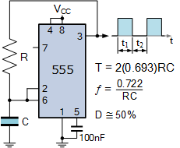

SIMPLE RC

Here we connect a feedback from the output to a capacitor connected pins 2 & 6.

We connect a 100 micro farad capacitor to the control voltage since we do not need it. Also, we don’t need pin 7.

TIMER WITH VARYING DUTY CYCLE

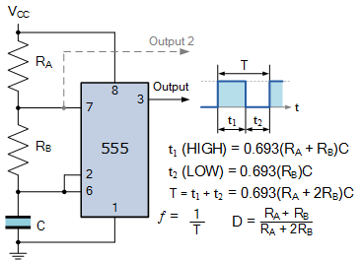

Acting as an astable we will use this implementation to realize our project.

The 0.693 is ln(2). If we connect resistors in such a way we have a ratio of resistors which enables us to have a varied period. We had an idea of using a potentiometer here since it allows us to vary the time constant

If we add an additional diode between 7 & 6 we will get a 50% duty cycle

intro

This project is about implementing the extended version of the classic game rock-paper-scissors called “Rock-Paper-Scissors-Lizard-Spock”. Two players will play the game by choosing 1 out of the 5 inputs (a character from the one cited above) and the game will consist about determine the winner relying on the rules of the game. We implemented a digital circuit that matches the inputs to combinational logic and outputs the winner character, winner of the round and the winner of the the game, on three different a 7-segments. It is important to mention that both players should play at simultaneously which means that the digital circuit should be synchronized and to do so we used a 555 timer

(the digital circuit and specially the implementation of the clock will be discussed in details in the following report).

Component:

|  |  |  |
| --- | --- | --- |
| Pushbutton:  The pushbutton are triggered by each player to insert the desired input | 10item |  |
| LEDs:  The LEDs are used to represent the input inserted by each player and one LED represents the clock. | 11 |  |
| 1 digit 7-segment display:  Each 7-segment lights up on a particular input.(one represents who won the round, the other what won the round,and finally who won the game. | 3 |  |
| Soldering iron: Used to solder the chairs and wires on the soldering board. | 1 |  |

|  |  |  |
| --- | --- | --- |
| Soldering wire:  Used to solder the chairs and wires using the soldering iron. | 1 |  |
| Soldering Board:  All the chairs, chips and wires are soldered on the board. | 3 |  |
| Y W Robot (voltage source):  Gives the circuit a constant Voltage. | 1 |  |
| Wires:  Used to connect the chips and ICs together on the soldering board. | 5 m of wires. |  |

|  |  |  |
| --- | --- | --- |
| 555 timer:  Used to provide a clock signal to the circuit. | 1 |  |
| Resistors and capacitors:  Used to protect the ICs from | 3 |  |
|  | 1 |  |
|  |  |  |